PYTHON strings

[Texts in python](https://www.w3schools.com/python/python_strings.asp)

Strings in python are wrapped in single quotation marks or double quotation marks. Python doesn't differentiate 'Hello'towards "Hello". For python, this is the same thing;

Multline strings

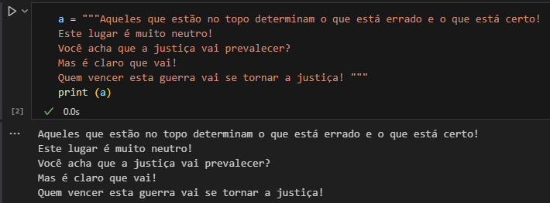 You can create a multi-line string using three double quotation marks or three single quotation marks:

Strings are arrays

Just like many other popular programming languages, in Pythonthe Strings are treated as array(lists) of bytes representing Unicode characters;

That is: strings in python can be treated as sequences of bytes stored in memory, where each byte represents a Unicode character.

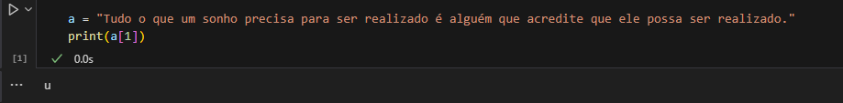 Another important piece of information is that python doesn't have a character data type. A single character means a string of such [1];

Remember that the first character is position "0".

Looping Through a String

Since Strings They're like Arrays, we can loop the characters in this string using Is:

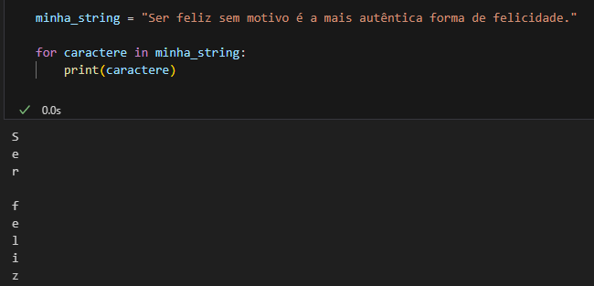

In this example, the 'for' loop iterates over each character in the 'minha_string' str and prints each character.

String Size

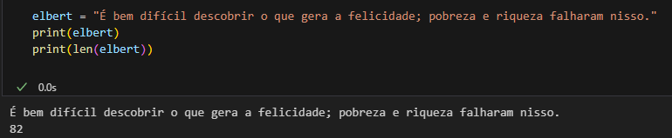To get the length of the string, use the len() function:

Check String

To check if a certain phrase or character is present in a string, we can use the keyword in.

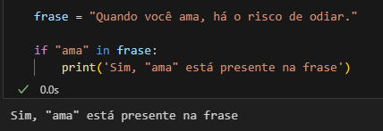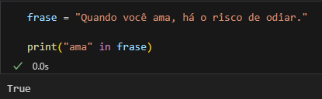

Check Absence

To check if a certain phrase is not present in a string, just use the keyword not in.

